University of Canberra
Faculty of Science and Technology

Software Technology 2
(7170)
Week 6 Tutorial & Computer Lab

Assignment 1: Individual Project
Part 3: Linear Data Structures (Linked Lists, Stacks, Queues and Priority Queues)

- This lab activity is assessed and contributes to the Assignment 1 (Individual Project) mark.
- Please go through Week 6 lecture recordings and Week_6_Tutorial_and Computer_Laboratory.doc available after Module 6 in Canvas (Assignment 1/Individual Project preparation activities)
- For assessment of this activity, you need to complete the following in week 6 tutorial/lab:
  - attend your allocated computer lab class in Week 6,
  - complete all tasks listed in this handout,
  - demonstrate the working activities to your tutor in class, and
  - Save your python project to a zip file and upload this zip file to In-class Lab Work Demo Week 6 and upload it to your GitHub Repository. Make sure you include a commit message with date and time, when you upload this zip file in GitHub.
- Your mark is 0 if you do not demonstrate your project.
- You can leave the class after you complete the 4 requirements above.

Tasks
- Understanding Linear Data Structures (linked lists, stacks, queues and priority queues and their implementation in Python (data_structures_practice.py)
- Benchmarking Performance of Linear Data Structures (data_structures_practice.py)
- Prior Reading: Week_6_Lecture available in Module 6 in Canvas.

Download the Week_6_Lab_Activities.zip after Module 6 in Canvas, and unzip the folder. This folder content contains all the necessary activities needed for each task completion in this week.

Task 0: Background (Not assessed) – Refer Week 6 Lecture in Canvas
Understanding Linear Data Structures (Linked Lists, Stacks, Queues and Priority Queues)
- Why data structures matter ?
- Data Structures
  - Linear (Linked Lists, Stacks, Queues, Priority Queues …)
  - Nonlinear (Trees, Graphs … )
- Linked Lists, Stacks, Queues, Priority Queues
- Comparison and use cases

  - Why Data Structures?
    - Efficient data organization and retrieval
    - Impact on performance & memory
    - Real-world examples: Browsers, OS, task schedulers, algorithms

    - What is a Linked List?
      - Collection of nodes
      - Single linked list and Double linked list
      - Each node contains data and pointer to next
      - Can be singly or doubly linked
      - Dynamic size – no fixed size limit

    - Linked List - Advantages & Disadvantages

Advantages | Disadvantages
Dynamic memory utilization | No random access (O(n) traversal)
Easy insertion and deletion | More memory usage due to pointers
Ideal for unknown or changing sizes | Comparatively slower than arrays

  - What is a Stack?
- LIFO (Last In First Out) data structure
- Only top element accessible
- Operations: push (insert), pop (remove), peek (view top)

  - Stack Use Cases
- Undo functionality
- Syntax parsing
- Back button in browsers
- Expression evaluation

  - What is a Queue?
- FIFO (First In First Out) data structure
- Insert at rear, remove from front
- Operations: enqueue, dequeue, peek

  - Queue Use Cases
- Task scheduling
- Data buffers
- Handling requests

  - What is a Priority Queue?
- Like a queue but elements have priorities
- Element with highest priority served first
- Typically implemented with heaps

  - Priority Queue Use Cases
- CPU scheduling
- Dijkstra's shortest path algorithm
- Event-driven simulation

  - Comparison Table
Data Structure | Access Time | Insertion Time | Deletion Time | Use Cases
Linked List | O(n) | O(1)/O(n) | O(1)/O(n) | Dynamic size lists, undo logs
Stack | O(1) (top) | O(1) | O(1) | Expression evaluation, call stacks
Queue | O(1) (front) | O(1) | O(1) | Task scheduling, buffering
Priority Queue | O(log n) | O(log n) | O(log n) | Task prioritization, graphs

- When to Use Which?
  - Use Linked List for dynamic memory, easy inserts/deletes at head or tail
  - Use Stack for LIFO needs (undo, parsing)
  - Use Queue for FIFO processing (printing jobs, requests)
  - Use Priority Queue for tasks with importance levels
  - Some Python data structure tools: lists, deque, heapq
  - Choose appropriate DS based on use case & performance needs

- Task 1: Linked Lists, Stacks, Queues, and Priority Queues
- Run the script linked_lists_practice.py for testing the simple python lists, single linked and double linked list data structure code and benchmark their performance for different data sizes. Report on the performance (screenshots)for each data size. Currently it is set for 1000. Test it for 10000 and 50000.
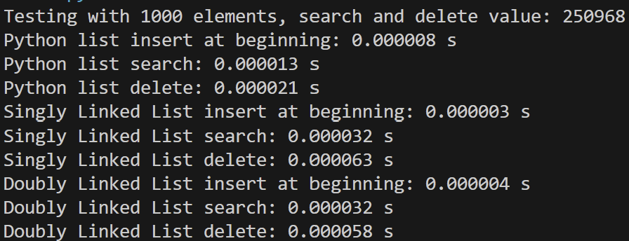

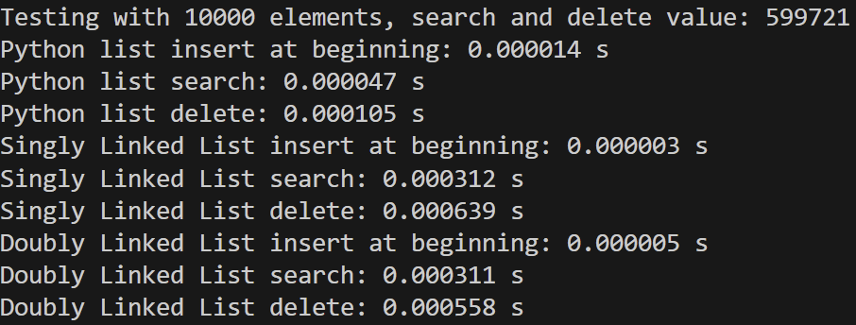

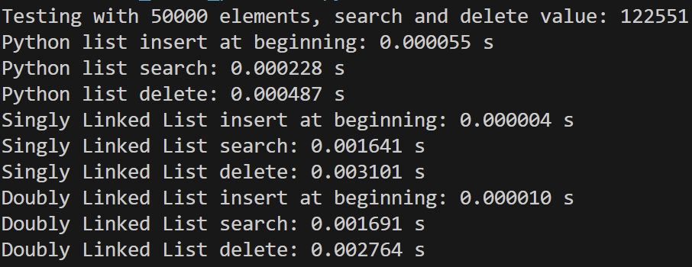

- Run the script stacks_queues_practice.py for testing the stack, queue and priority queue datastructure code and double linked list code and comparing their performance for different data sizes. Report on the performance (screenshots) for each data size. Currently it is set for 1000. Test it for 10000 and 100000.
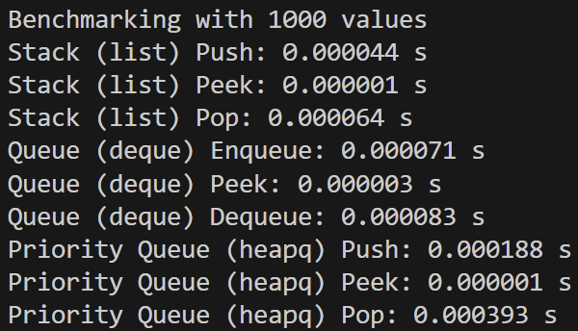

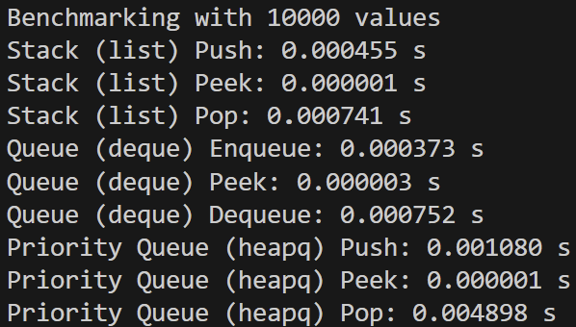

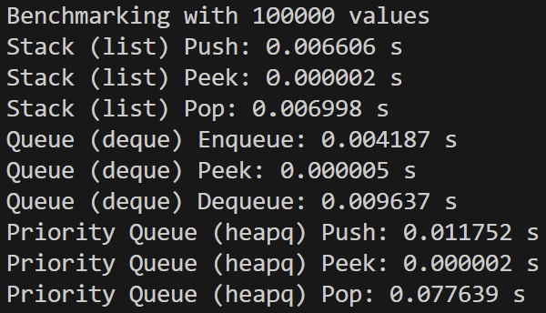

Task 2: Visualising Linked Lists
- The python script double_linked_list_visualiser.py allows visualisation of search, insertion and delection in a double linked list (dll). A successful test execution of this script should display the following GUI interface:

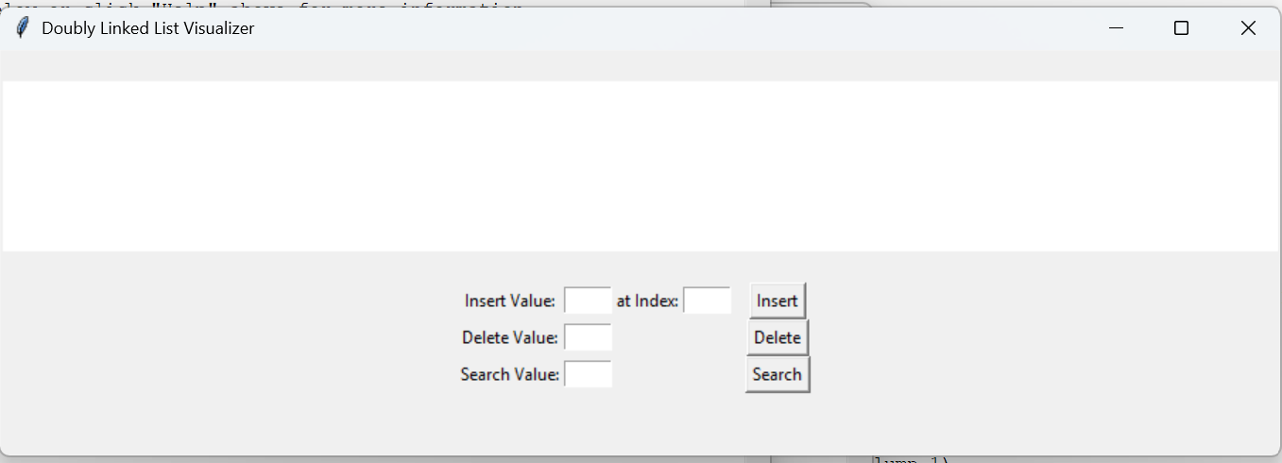

- Test the code for inserting a list of integers (10,20,30, 40.50), and report the results (screenshots) for visualising insertion, search and deletion operations.

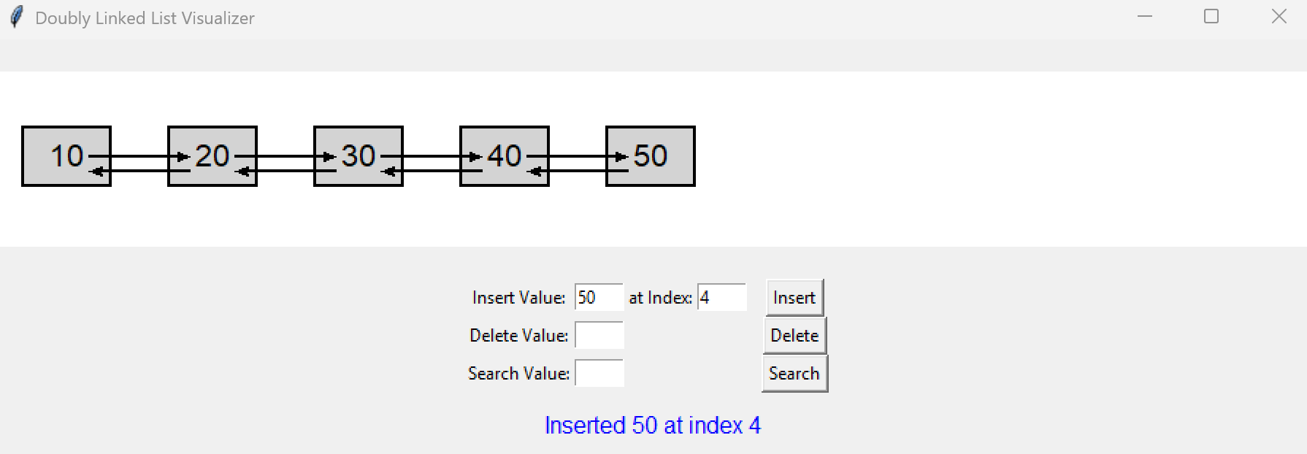
  - Test results (screenshots) when the Insert button inserts the value into the specified index in the dll list.

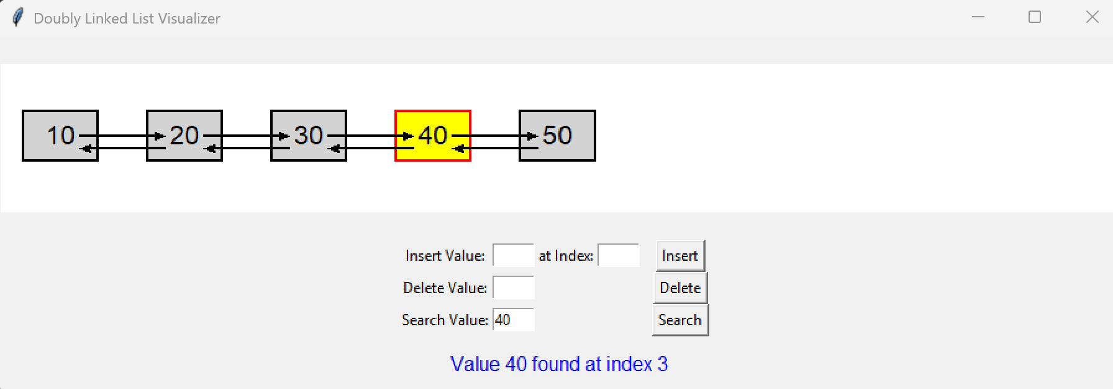
  - Test results when the Search button searches whether the specified value is in the dll list.

  - Test results when the Delete button deletes the specified value from the dll list.
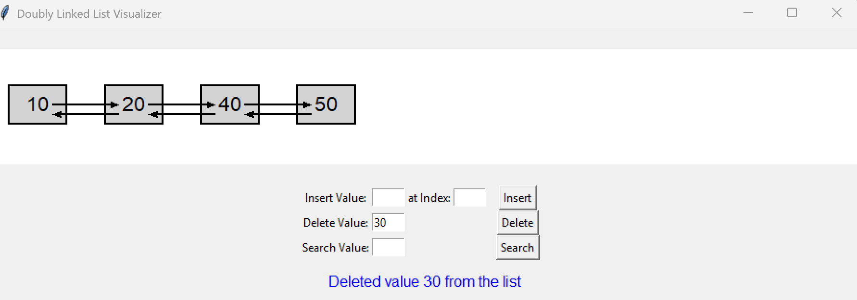
  - Modify the visualiser code for this task to allow visualisation of single linked list. You can use the relevant classes from Task 1 related to single linked lists to write this single linked list visualiser.
  - Show the GUI layout of a successful test run for this script.
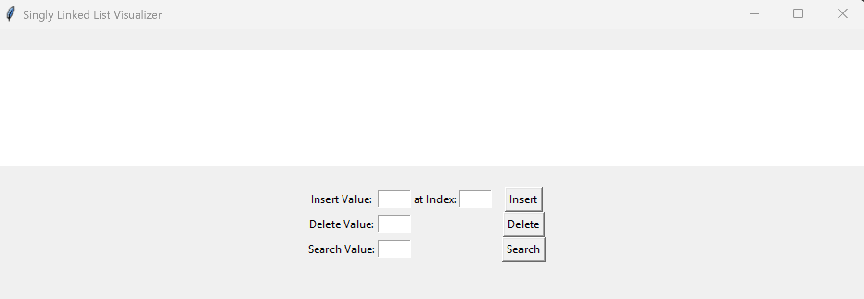

  - Submit the code as single_linked_list_visualiser.py
  - Show the results (screenshots) for insert, search and delete button operations (same test data - list of integers (10,20,30, 40.50) )
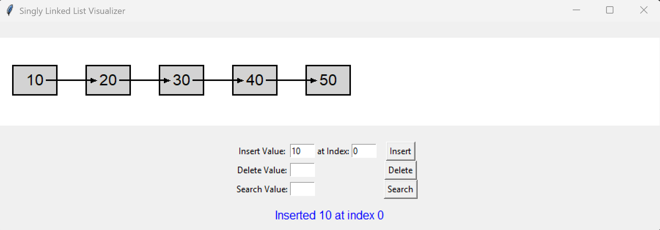
  - Test results when the Insert button inserts the value into the specified index in the sll list.
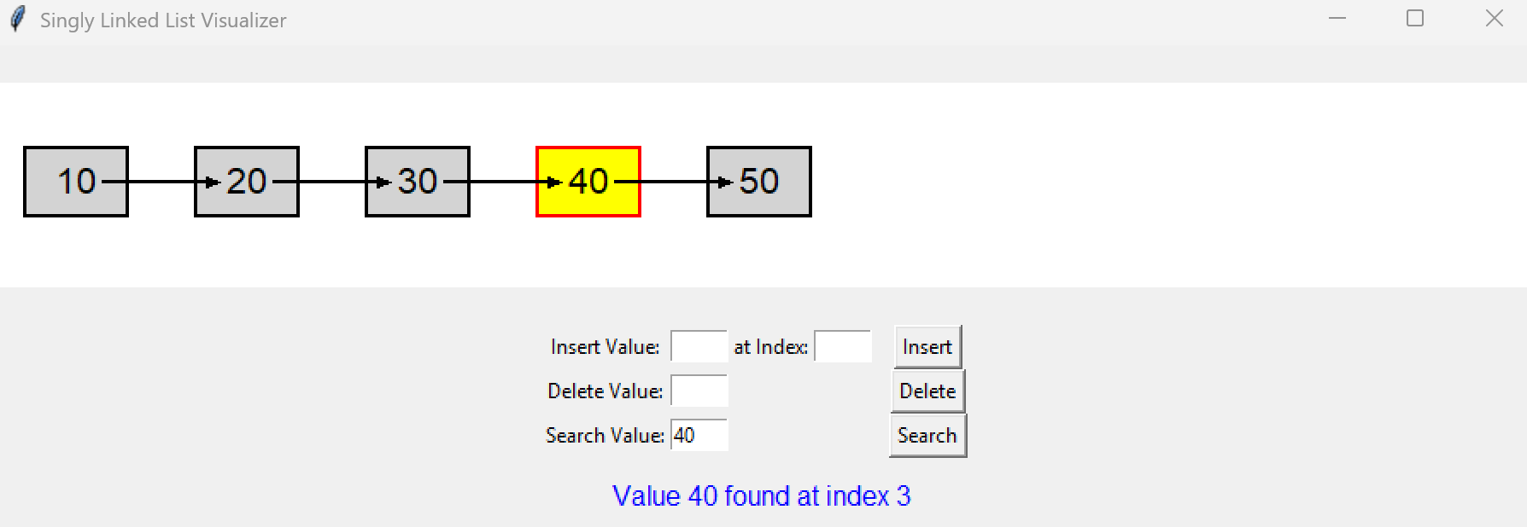
  - Test results when the Search button searches whether the specified value is in the sll list.

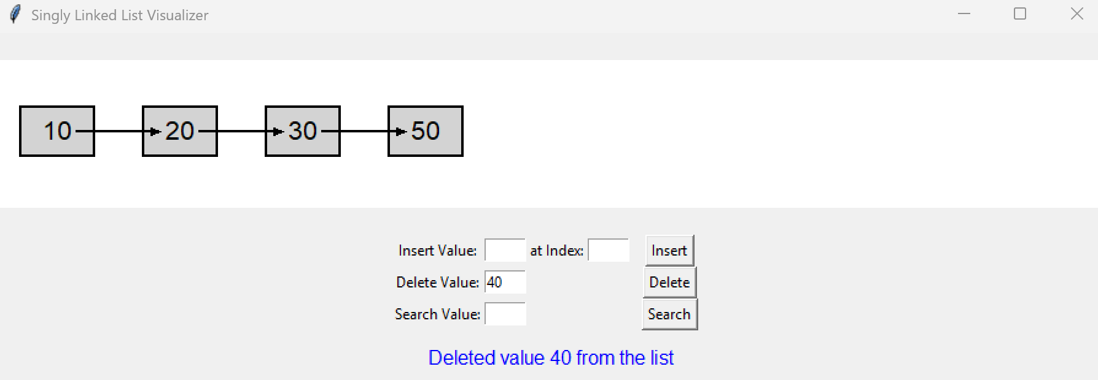
  - Test results when the Delete button deletes the specified value from the sll list.

Task 3: Visualising Stacks and Queues
- The python script stack_visualiser.py allows visualisation of LIFO push and pop operations for stack data structure. A successful test run of the code show display the following:
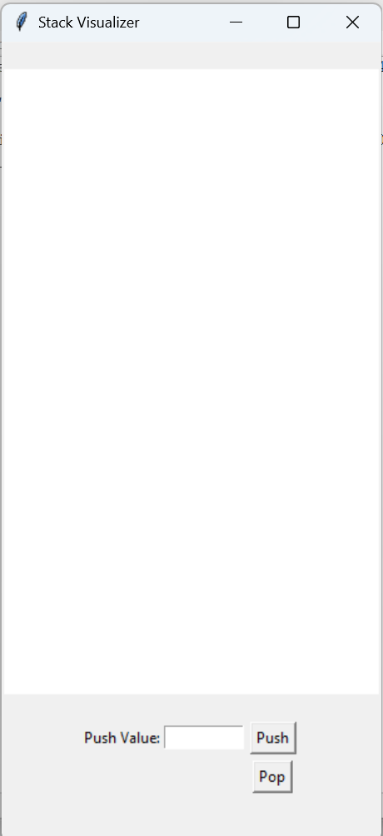
Test the visualiser for pushing a list of integers [10,20,30,40,50] and popping the list. Show the results (screenshots) of how the push and pop operations for a stack are performed in a LIFO order.
  - Test results when the Push button inserts the value in the stack
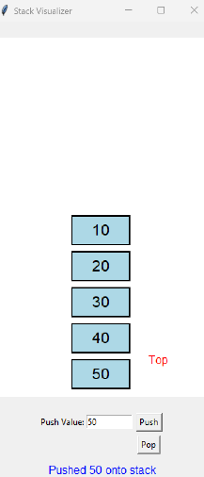

  - Test results when the Pop button retrieves value from the stack.
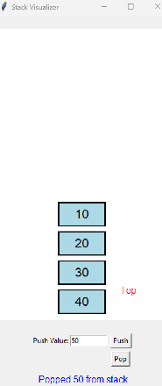

  - Modify the visualiser code for this task to allow visualisation of queue . You can use the relevant classes from Task 2 related to queues to write this queue visualiser.
  - Show the GUI layout of a successful test run for this script.
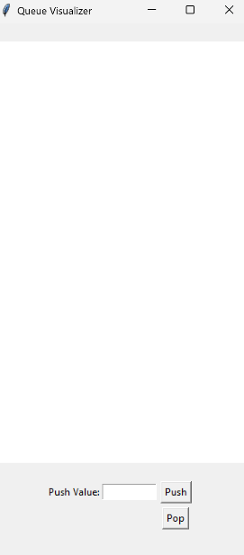

  - Submit the code as queue_visualiser.py

  - Show the results (screenshots) for push and pop button operations (same test data - list of integers (10,20,30, 40.50) )
  - Test results when the push button inserts the value into the queue.
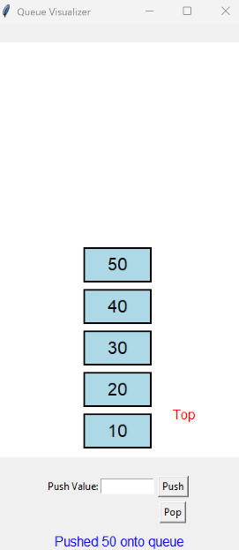

  - Test results when the pop button retrieves the specified value from the queue.

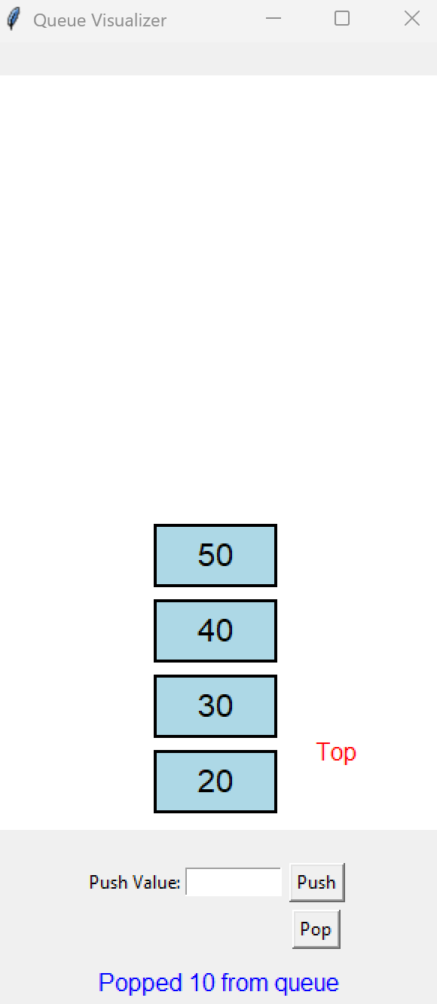

Task 4: Visualising Priority Queues
- The python script priority_queue_visualiser.py allows visualisation of FIFO push and pop operations for priority queue data structure. A successful test run of the code show display the following:
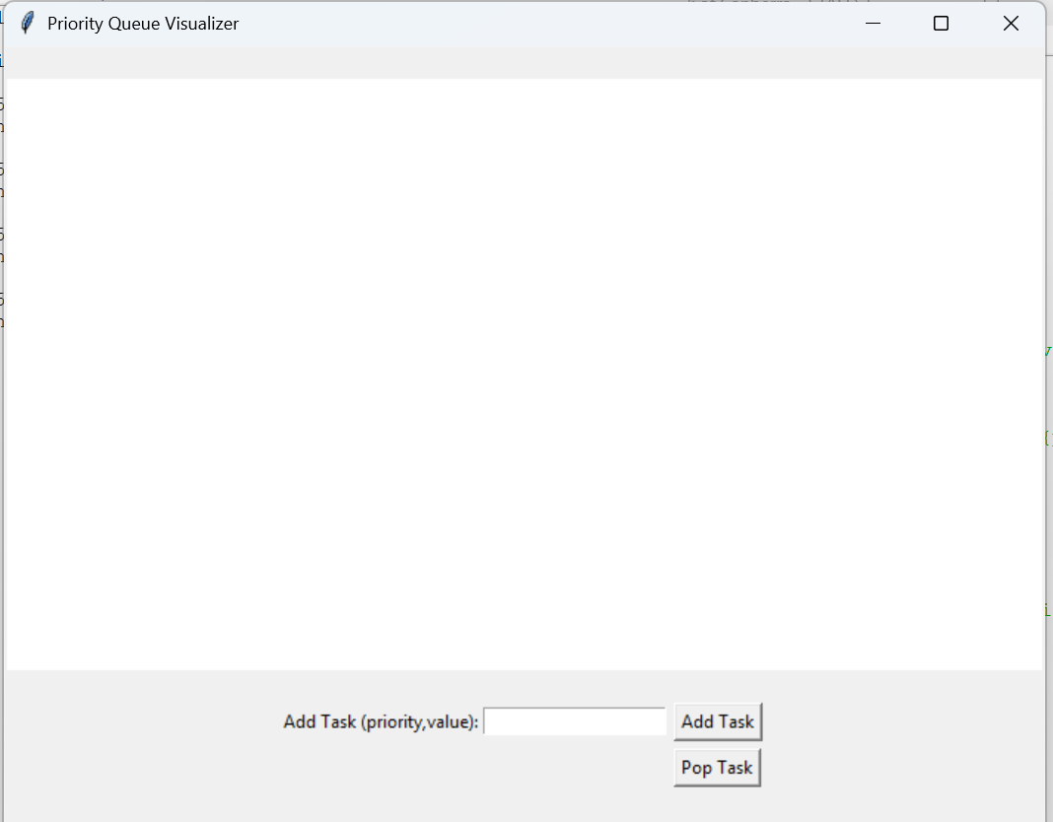

Test the visualiser for pushing a sequence of tasks with priority in terms of priority and value.
For example (1, Eat), (2,Sleep), (3, Work). Show the results (screenshots) of how the push and pop operations for a priority are performed in FIFO, but based on priority assigned.
  - Test results when the Add Task button is used to insert tasks with priority value
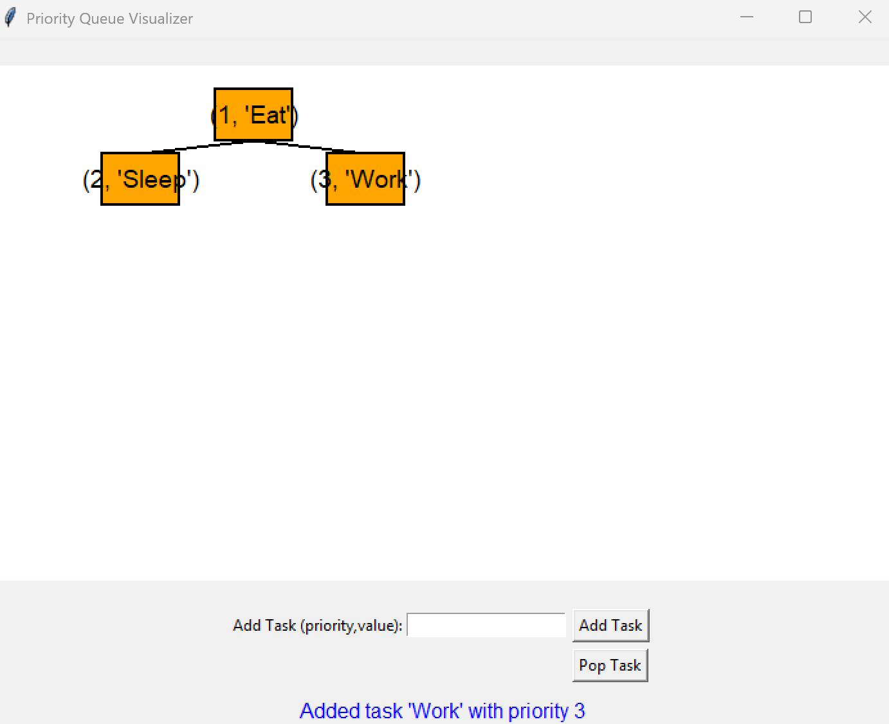

  - Test results when the Pop Task button retrieves value from the stack.
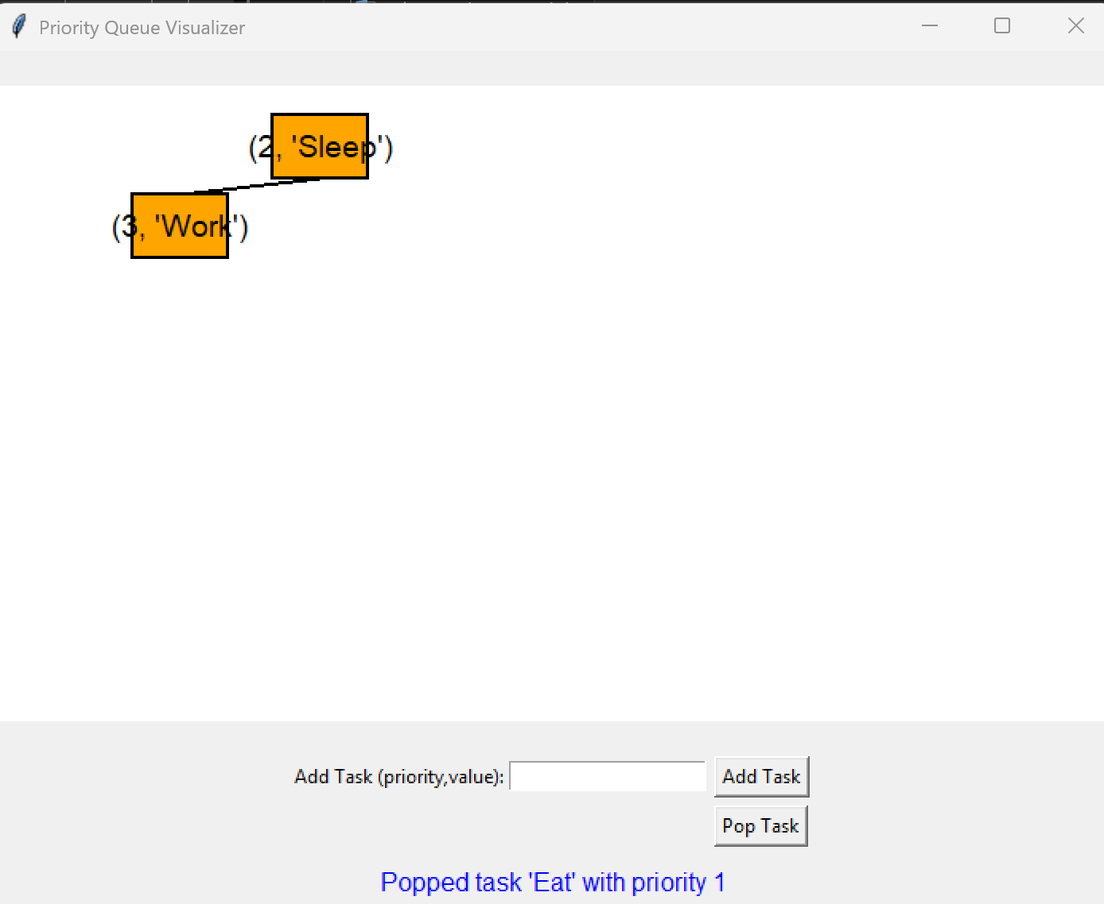

  - Please complete this report with your python scripts and test results, and your comments for each task in relation to the questions asked.
  - Demonstrate/present the tasks to your tutor in class.
  - Prepare a report, similar to this handout, but with code/scripts and results included for your tests for each task, and save the report as Week_6_lab_report.pdf.
  - Include this report as well as python scripts for each task (task 1 to task 4) in a separate folder and zip it, with a title (Week_6_LabAcitivities.zip).
  - Upload the zip file to your github repo, and add a commit message with date and time details.
  - You can leave the lab now. Please note your mark is 0 if you do not present/demonstrate your working project in lab class. This must be done in Week 6.
Mark for this tutorial: 8 marks

